Lab No: 6 Developing Web Application using Django – Part II

Name : Ketan Goud
Reg No: 220905260
Section: D D2
Roll No: 39

LAB ASSIGNMENTS:
1) Develop a simple web page to perform basic arithmetic operations. Take two integer inputs from the user, select the operation to be performed using a drop down. Include a button “Calculate” to perform the selected operation, and then display the result in the same web page.
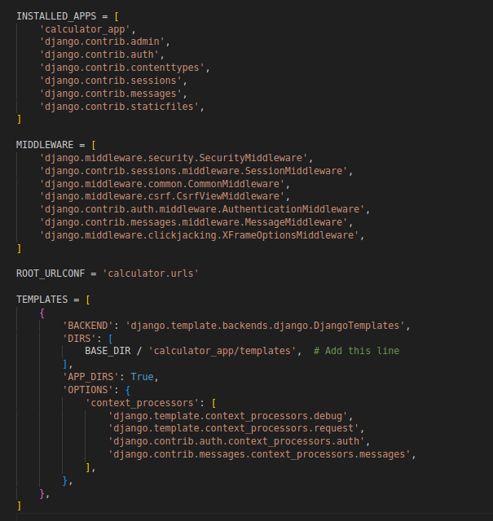

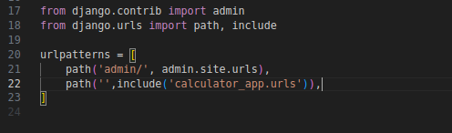

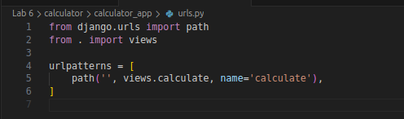

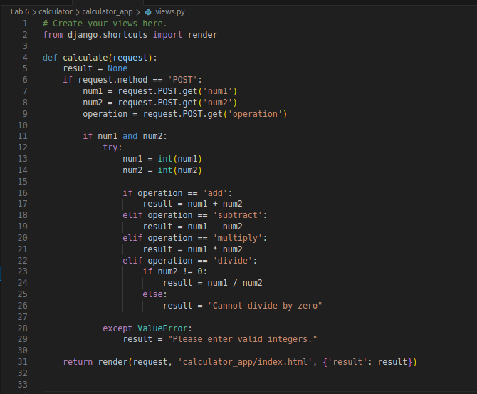

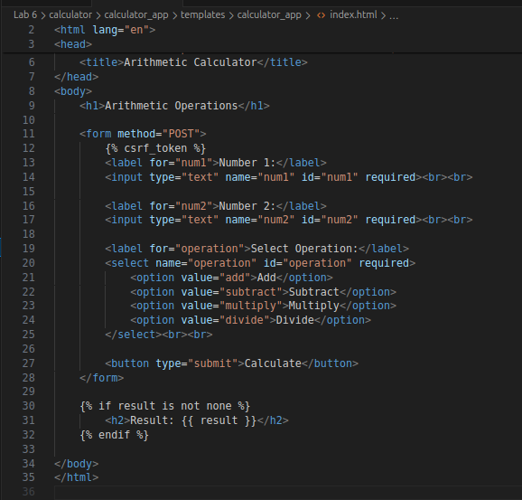

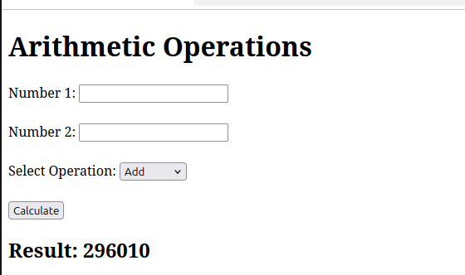
2) Develop a simple web form that generates the front cover for a magazine. The form should provide the options for selecting the image, background color, changing font size, color etc. Input messages must be taken from the user so as to display it on the front cover with legible font family and font size. The front cover developed should be proportionate to the web page size. Place the css files inside static folder.

